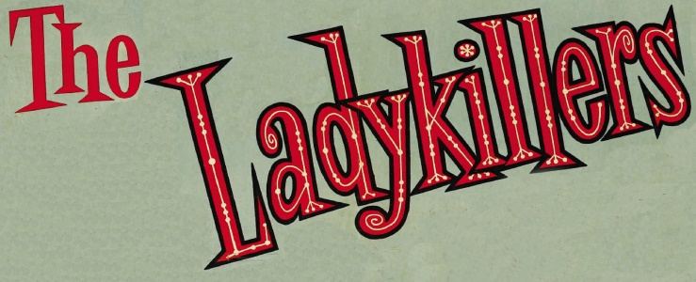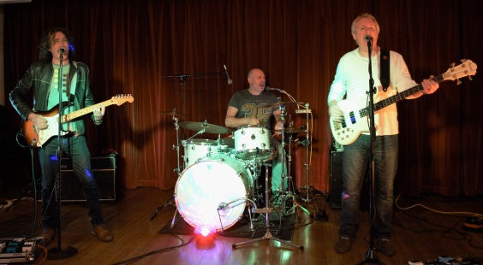

http://57royall.wix.com/ladykillersplymouth#!epk/ch29
https://www.youtube.com/channel/UCT6MG4qcr8HPH66bhGzoKoA
https://www.facebook.com/TheLadyKillersPlymouth/
https://www.lemonrock.com/ladykillers

The LadyKillers are a 3 piece rock band, based in the Southwest. The band play guitar based rock/pop featuring the compositions of David Behennah, together with a sprinkling of covers. The aim is to get people on their feet dancing and we’ve never failed yet.
deciBelle were formed in 2014 when David Behennah asked Geoff Royall if he was interested in revisiting some old material, written by Dave back in the early 80's and performed with Geoff in the Band Night After Night. Barely a year passed before Dave, with Geoff, had revisited, revised, and recorded a small set of demo songs, to present to a drummer who might be interested in joining a band. That's when things got really interesting.
Geoff asked Keith Russell and he said yes. Keith added his considerable drumming skills and applied his superb organisational talent, and suddenly everything started to happen really quickly. So here we are, 20+ songs in the bag and ready to go.

There’s a wealth of experience in the band, with over 100 years of gigging time logged between the three members. Between them Dave, Geoff and Keith have appeared in most of the venues, pubs and clubs across the West Country. Their range of musical experience includes rock, pop, folk, acoustic solo, brass bands, jazz – you name it, one of them will have done it. Highly experienced performers, they’re capable of giving you a show, no matter what the venue is.

The LadyKillers are:

David Behennah – Guitar/Vocals
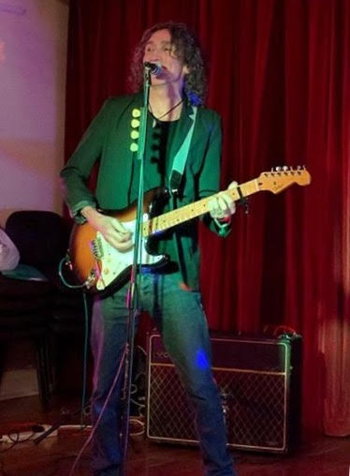
Singer songwriter D.B. sees himself as a traditionalist in his approach to making music – ‘When I play live all I have is my voice, a guitar and a head full of songs’. Add to this what The Stage called ‘witty asides’ and you have an artist capable of working any venue at any time. He has recently appeared at The Excel Arena in London, The Fleece in Bristol, and the ‘Crown & Banjo’ in a town near you.
In the past he has been seen and heard on BBC TV and Radio, ITV, at the legendary Marquee Club and on tour in continental Europe. He is inordinately proud of his contribution to the world of motion picture soundtracks; his ‘Emotional Refugee’ features in the straight to DVD classic ‘The Class of Nuke ‘em High’.
David also works extensively around Devon & Cornwall, known to many as Dave Banana, solo artist, guitarist/vocalist, prolific songwriter, humourist. Dave can be seen at many venues around the SW and also works with Rick O'Shay as one of the Sensational Barnet Brothers.
His influences include:
Springsteen, Steve Earle, Sinatra, Haruki Murakami, The Rolling Stones, Daphne du Maurier, Paolo Nutini and Max Miller.

Geoff Royall – Bass/Vocals
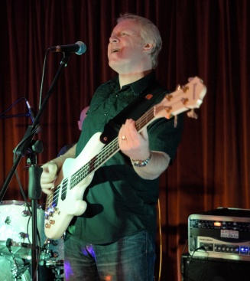
White van driver, retired hedonist. Geoff is a founder member of the function band, deciBelle, playing at a wedding near you most weekends. Geoff was a founder member of a successful 3-piece band with Dave Behennah & Lee Knights in Night After Night in the 80’s. Next stop was 80’s cover band Driven By Italians, before moving onto folk/rock ceilidh band Eddie and the Lighthouses, whose main claim to fame was opening the Elephant Fayre Folk Festival.
He teamed up again with Dave Behennah to form a duo, The Chosen Two, clocking up a respectable 150 gigs a year playing around clubs and holiday camps throughout the South West, before joining up with Time & Motion, in the mid 90’s, staying with this long running group for over 6 years until the band folded. After a stint with Smiler, and depping in several bands, he helped to form deciBelle in early 2009.
His influences include:
Del Amitri, Family, Sid James, The Rolling Stones, Bill Wyman, Daryl Jones, Ducks Dunn and Bill Bailey.

Keith Russell – Drums/Vocals

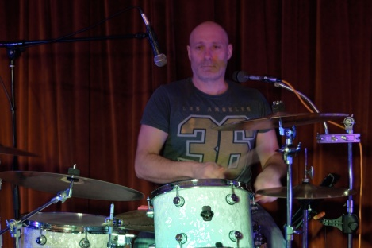
Keith Russell is a freelance drummer based in Plymouth, UK.
Hailing from Lichfield and cutting his teeth on the social club scene in Yorkshire, Keith has played for numerous bands in the South West including several years with 'Vince Lee and the Big Combo'; with whom he has recorded two albums, 'Call It What Ya wanna' and a new CD to be released soon.

Keith currently drums for 'The Breaks' (with his son Joe Russell), 'Jessica and the Rabbits', 'The Ladykillers' and many jazz line ups. He holds the drum chair with Soundhouse Brass and is a jazz regular at the Tuesday night sessions at the Union Inn, Saltash.

As a depping drummer, Keith is always up for new challenges! He also teaches drums so get in touch if you would like lessons.

THE LADYKILLERS SET LIST
PART ONE:
TOO PRETTY TO CARE
GOSPEL OF PASSION
GO GO BOOTS
DEAD FLOWERS
RISK BUSINESS / BACKSTABBERS
SIXTIES CHICK
Fire (Acoustic)
Whistle for the Choir (Acoustic)
IN MY BROTHER’S ROOM
RACING FOR THE PROMISES
CLOSE TO YOU
BAD LUCK/LOVE TROUBLE

PART TWO:
GIVE UP THE GHOST
HURRY HOME
LOVE ON THE RUN
ACT OF VIOLENCE
ANOTHER MORNING IN TUCSON
No Wasted Days (Acoustic)
I CAN’T HELP MYSELF
ANGELITA
I’M A BELIEVER
THINK IT OVER
DRUNK IN A BAND

Price Guide
The band operates out of Plymouth and serves the South West of the UK – maximum travel time is 2 hours.
Fees for public houses and small events can be as low as £200, dependent on location and time of year.
Corporate Events - £500 to £1200, dependant on size of event and travel time.
Weddings - £550 to £900, dependant on size of event and travel time.
For travel to gig over one hour, add £100 to the overall fee.
For playing past midnight, add £100 to the overall fee.
The above fees include up to 2 45 minute sets, to be completed by midnight, unless specifically arranged. The band carries its own comprehensive Public Liability Insurance (through the Musician’s Union) and all equipment is PAT tested. The band can also provide background music between sets using our own playlists, or those provided by the client.

